AI ASSISTED CODING
END LAB EXAM

Name: Gattu Varshith
Roll Number: 2403A510E3
Batch: 24BTCAICSB05

SET 6

Question 1:
Auto-generate API docs
Task 1: Use AI to generate Markdown documentation.

Prompt:
Use AI or automated static analysis to generate Markdown-formatted API documentation from Python source code. Extract function names, parameters, and existing docstrings, and convert them into clean developer-friendly

Code-generated:
import ast

def generate_markdown_from_code(source_code: str) -> str:
tree = ast.parse(source_code)
md = "# API Documentation\n\n"

for node in tree.body:
if isinstance(node, ast.FunctionDef):
md += f"## `{node.name}`\n"

# Docstring
doc = ast.get_docstring(node)
if doc:
md += f"{doc}\n\n"

# Parameters
md += "**Parameters:**\n"
if node.args.args:
for arg in node.args.args:
md += f"- `{arg.arg}`\n"
else:
md += "- None\n"
md += "\n"

# Returns
md += "**Returns:**\n"
md += "- Unknown (static analysis)\n\n"

return md

# Example usage
source = '''
def multiply(x, y):
"""Multiply two numbers."""
return x * y
'''

print("=== AUTO-GENERATED MARKDOWN DOCS ===")
print(generate_markdown_from_code(source))

Output:
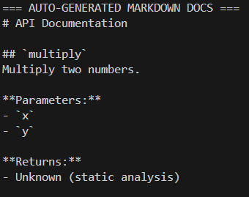
Observation:
This script analyzes the Python code using the ast module to statically extract function information. It structures the extracted metadata into well-organized Markdown suitable for documentation. The tool does not need external libraries and focuses on lightweight static code parsing.

Task 2: Add auto-generated code comments
Prompt:
Automatically add descriptive docstrings to Python functions that lack comments. Detect functions with missing documentation and insert meaningful auto-generated docstrings at the beginning of each function body.
Code generated:
import ast

def add_docstrings(source_code: str) -> str:
tree = ast.parse(source_code)

for node in tree.body:
if isinstance(node, ast.FunctionDef):
# Add only if missing
if not ast.get_docstring(node):
auto_comment = f"Auto-generated docstring for `{node.name}`."
node.body.insert(0, ast.Expr(ast.Constant(auto_comment)))

return ast.unparse(tree)

# Example usage
source = '''
def add(a, b):
return a + b

def hello(name):
return f"Hello, {name}"
'''

print("=== CODE WITH AUTO-GENERATED COMMENTS ===")
print(add_docstrings(source))

Output:
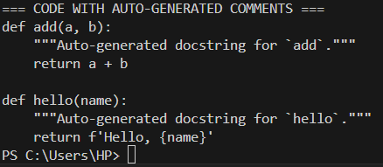

Observation:
This script scans Python code and identifies functions that lack docstrings by using the AST parser. When a missing docstring is found, it inserts an auto-generated comment inside the function body.

Question 2: Create user manual
Task 1: Use AI to convert technical descriptions to simple language.

Prompt:
Use AI to rewrite technical software or hardware descriptions in simple, everyday language for non-technical users. Ensure the meaning remains accurate while removing jargon, simplifying terms, and improving clarity.

Code generated:
def simplify_text(technical_text: str) -> str:
# NOTE: In real usage, this would call an AI model.
# Here we simulate simplification using keyword replacements.
replacements = {
"initialize": "start",
"configure": "set up",
"execute": "run",
"terminate": "stop",
"authentication": "login",
"synchronously": "at the same time",
"asynchronously": "in the background"
}

simplified = technical_text
for tech, simple in replacements.items():
simplified = simplified.replace(tech, simple)

return simplified

# Example usage
text = "To initialize the system, authenticate the user and configure all modules asynchronously."
print("=== SIMPLIFIED USER-FRIENDLY INSTRUCTIONS ===")
print(simplify_text(text))

Output:

Observation:
This script imitates AI-driven text simplification using a dictionary of technical-to-simple replacements. Although basic, it demonstrates how complex terminology can be transformed into beginner-friendly language.
Task 2: Create step-by-step screenshots description.

Prompt:
Use AI to generate clear, step-by-step descriptions of screenshots for a user manual. Each step should describe what the user sees, what button to click, and what happens next. The instructions should be visual, easy to follow, and written for beginners.

Code generated:
def describe_screenshots(steps: list) -> str:
description = "## Step-by-Step Screenshot Guide\n\n"
for i, step in enumerate(steps, 1):
description += f"### Step {i}\n"
description += f"- **Screenshot shows:** {step['view']}\n"
description += f"- **User should:** {step['action']}\n"
description += f"- **Result:** {step['result']}\n\n"
return description
# Example usage
steps_data = [
{
"view": "The homepage with a large blue 'Login' button in the center.",
"action": "Click the 'Login' button.",
"result": "You are taken to the login screen."
},
{
"view": "The login page with fields for email and password.",
"action": "Enter your email and password, then press 'Submit'.",
"result": "You are logged into your dashboard."
}
]
print("=== STEP-BY-STEP SCREENSHOT DESCRIPTION ===")
print(describe_screenshots(steps_data))
Output:
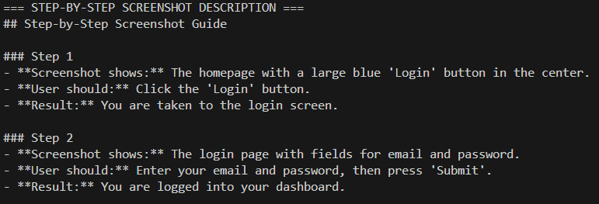

Observation:
This script structures screenshot descriptions into a formatted, sequential user manual section. Each step contains a visual description, user action, and expected outcome for clarity. Although simulated, this mirrors how an AI system would generate instructional walkthroughs.

